Current Overview:
BearingPoint has built two applications, a Workplace Management application driven by Extension Mobility requests, which subsequently was rolled into the more substantial Cross Cluster Extension Mobility. CCEM is currently in production on two Application Servers located behind a CSS for load-balancing and redundancy, and can interoperate with 3.3.3sr4a or 4.1 CCM Clusters.

Historical Overview:
BearingPoint approached the platform as a developmental environment. In September 2004, discussion began on what types of applications could/would be created on the platform.

By mid-October 2004, focus turned to a workplace-management and tracking application by creating an application which stands in front of Extension Mobility Login/Logout requests, which are then logged to a database for record keeping. This first application was done by mid-December 2004, and in production and without issue shortly thereafter.

Mid-December discussion turned to CCEM development. Until March, discussion continued on the needed components in the Application Server for this application, as well as the structure and design of the application itself. Metreos provided assistance in ironing out the details of CCEM with some additional help from mtinmaz@cisco.com (Mustafa Tinmaz – primary support contact for BearingPoint) and developer support at Cisco.

BearingPoint went into production with CCEM roughly around the beginning of September. A substantial memory leak was immediately observed. The issue lay in the Novell LDAP code. A second memory leak was discovered and resolved by the beginning of November. From this point on, there have been virtually no issues.

Architecture:
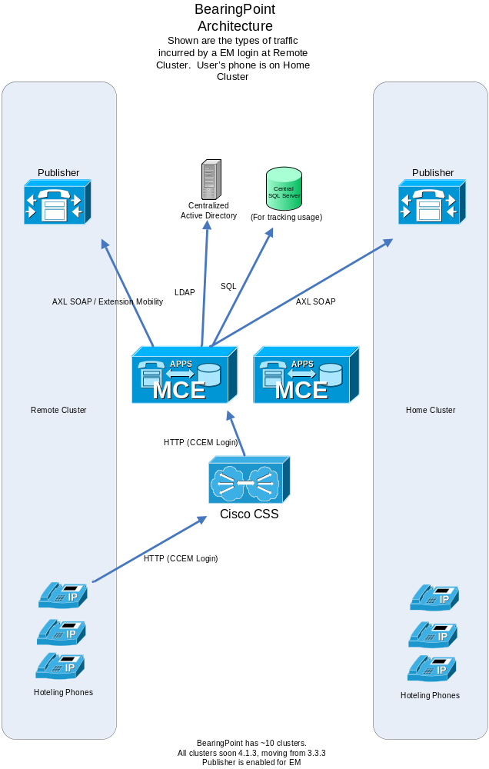

Contacts:
Most communication with BearingPoint occurs with their developer, Joe Auffermann joe.auffermann@bearingpoint.com, 917.327.8366) Periodically Steve Powsner (steve.powsner@bearingpoint.com, 917.805.6252) will also bring up an issue or float an idea.

